Record-breaking application running for ten years with 100% reliability

Still a world record: The world's longest plastic energy chain with 615 m travel comes from igus

Running continuously for 24/7 or standing idle for month on end – these are the extreme conditions that the world's longest plastic energy chain has to cope with at the lignite-fired power station in Tušimice, Czech Republic. The roller energy chain system from igus has been achieving this for ten years now without missing a beat on the record travel length of 615 metres.

In normal operation, lignite (brown coal) is extracted from the opencast mine and conveyed directly into the lignite-fired power station. However, if coal production is interrupted for any reason, it goes without saying that supplies must continue to go on generating energy. The operators of the power station, the ČEZ Group, do this by stockpiling large quantities of coal nearby. At Tušimice the coal is stored in a long heap on the periphery of the power plant site, which theoretically could be used to fuel the power station for a full week. To pile the coal automatically on the heap, a 'stacker' is used. To supply the stacker with energy, data and media, the ČEZ Group opted for an energy chain system from igus. Result: 615 m travel – a world record.

10 years of reliable operation in award-winning application
The application in Tušimice was awarded the golden vector award back in 2010. Every two years, igus initiates this competition to select the toughest and most exciting energy chain applications. Ten years later, this system is still working extremely hard, with plenty of life still left in it.

The project was managed by Hennlich, a stocking distributor for igus based in the Czech Republic. At the Tušimice power station the 5050RHD energy chain is used. The 'R' in the name stands for 'rollers'. "By using a roller, the coefficient of friction on long travels drops dramatically, when the upper run of the chain runs on the lower run," explains Frank Schlögel, Head of Engineering Projects, Sales & Marketing at igus. "Because of the lower friction, up to 57 percent of the required drive energy can be saved. Which, of course, is all the more worthwhile on record-breaking travels like this one." With his project engineering team, Frank Schlögel supervises special projects around the globe and accompanies customers closely in every step. From the first design and detailed planning stages up to assembly and even maintenance.

Problems are a thing of the past
Before the igus energy chain system was installed at Tušimice, a cable drum was used. During the cold Czech winter, the cables froze up time and again which could result in failures and unplanned shutdowns.

These problems have been a thing of the past for ten last years. Working with Hennlich, igus developed a complete package for the application. Since then, only regular visual inspections have been carried out. The overall balance: Over the entire period, just ten crossbars have been replaced. A job done in a few seconds. Not counting the inspection walk along the 615 m travel.

Along with the 615-metre record travel, two more systems are being moved with roller energy chains from igus - one is a 400-metre travel, the other is 150 metres. The two systems supply the 'reclaimer', which removes the coal from the pile and transfers it to the conveyor belt that runs to the power plant.

Reliable routing and safe overall concept
Inside the energy chains are various chainflex cables from igus, which have been developed specifically for use in energy chains. In addition to the chainflex motor and control cables, a fibre optic cable is used for data transmission. "Bus cables are out of the question for these long travels, as the signal strength would be insufficient," says Frank Schlögel. A water hose is also routed in the chain together with a heating cable that prevents the water from freezing inside the hose. The water hose is needed for the sprayer at the end of the stacker. When the coal is mined and piled up onto the heap, there is a lot of dust. This is counteracted by continuous spraying.

Since commissioning, electronic monitoring has been carried out on the energy chain systems in Tušimice. This measures the push/pull forces of the chains and can switch off the system if the forces become too high. This can happen when debris enters the system, for example. In recent years, igus has further developed this form of 'condition monitoring', or isense as it is known and today offers machine builders modules for monitoring and predictive maintenance as an additional safeguard. Under the 'smart plastics' range, this includes break (isense EC.B) and push/pull (isense EC.P) monitoring modules. In the event of a chain break, the system can be switched off, so that further damage is avoided. To complement this the abrasion monitoring module (isense EC.W), measures the wear of the energy chain continuously to provide a reliable indication of the remaining service life of the system. This enables a planned replacement of the system without sudden failures.

Continuous operation as proof of quality
Admittedly, the stacker moves only at a moderate speed. About 20 minutes are needed to cover the 600 metres. And every now and then the system is not used for a whole month. But when the time comes and the coal needs to be conveyed to the heap or needed from there, the operator can trust that the system will work reliably with the igus energy chains regardless of the season. Even in these harsh conditions and after more than ten years.

PRESS CONTACT:  Oliver Cyrus  Head of Media and Advertising  igus® GmbH  Spicher Strasse 1a  51147 Cologne  Tel. 0 22 03 / 96 49-459  Fax +49 22 03 / 96 49-631  ocyrus@igus.de  www.igus.de/de/presse | ABOUT IGUS:  igus GmbH is a globally leading manufacturer of energy chain systems and polymer plain bearings. The Cologne-based family business has offices in 35 countries and employs 3.800 people around the world. In 2017, igus generated a turnover of 690 million euros with motion plastics, plastic components for moving applications. igus operates the largest test laboratories and factories in its sector to offer customers quick turnaround times on innovative products and solutions tailored to their needs.

The terms "igus", "chainflex", "CFRIP", "conprotect", "CTD", "drylin", "dry-tech", "dryspin", "easy chain", "e-chain", "e-chain-systems", "e-ketten", "e-kettensysteme", "e-skin", "flizz", “ibow”, "iglide", "iglidur", "igubal", "manus", "motion plastics", "pikchain", "readychain", "readycable", "speedigus", "triflex", "plastics for longer life", "robolink", and "xiros" are protected by trademark laws in the Federal Republic of Germany and internationally, where applicable.

Image captions:

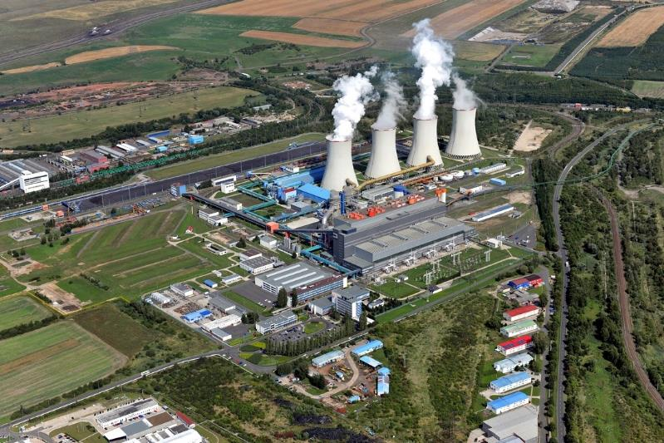
Image FA1418-1
The coal power station in Tušimice with the record-breaking application. On the top left is the stockpile of coal, next to which the 615 m roller energy chain operates. (Source: ČEZ-Group)

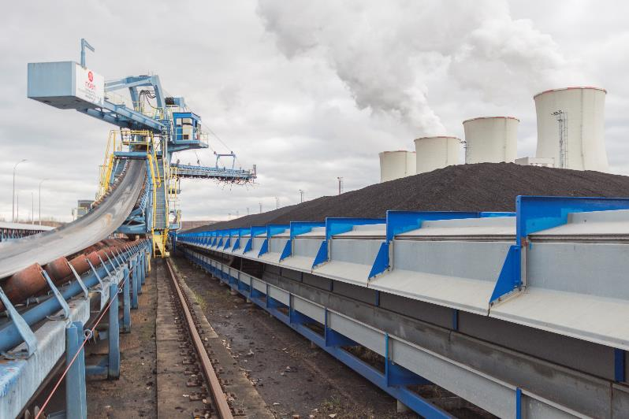
Image FA1418-2
The stacker piles the coal into a heap. It is supplied via cables and hoses with energy, data and media, which are safely routed by the longest plastic energy chain in the world. (Source: igus GmbH)

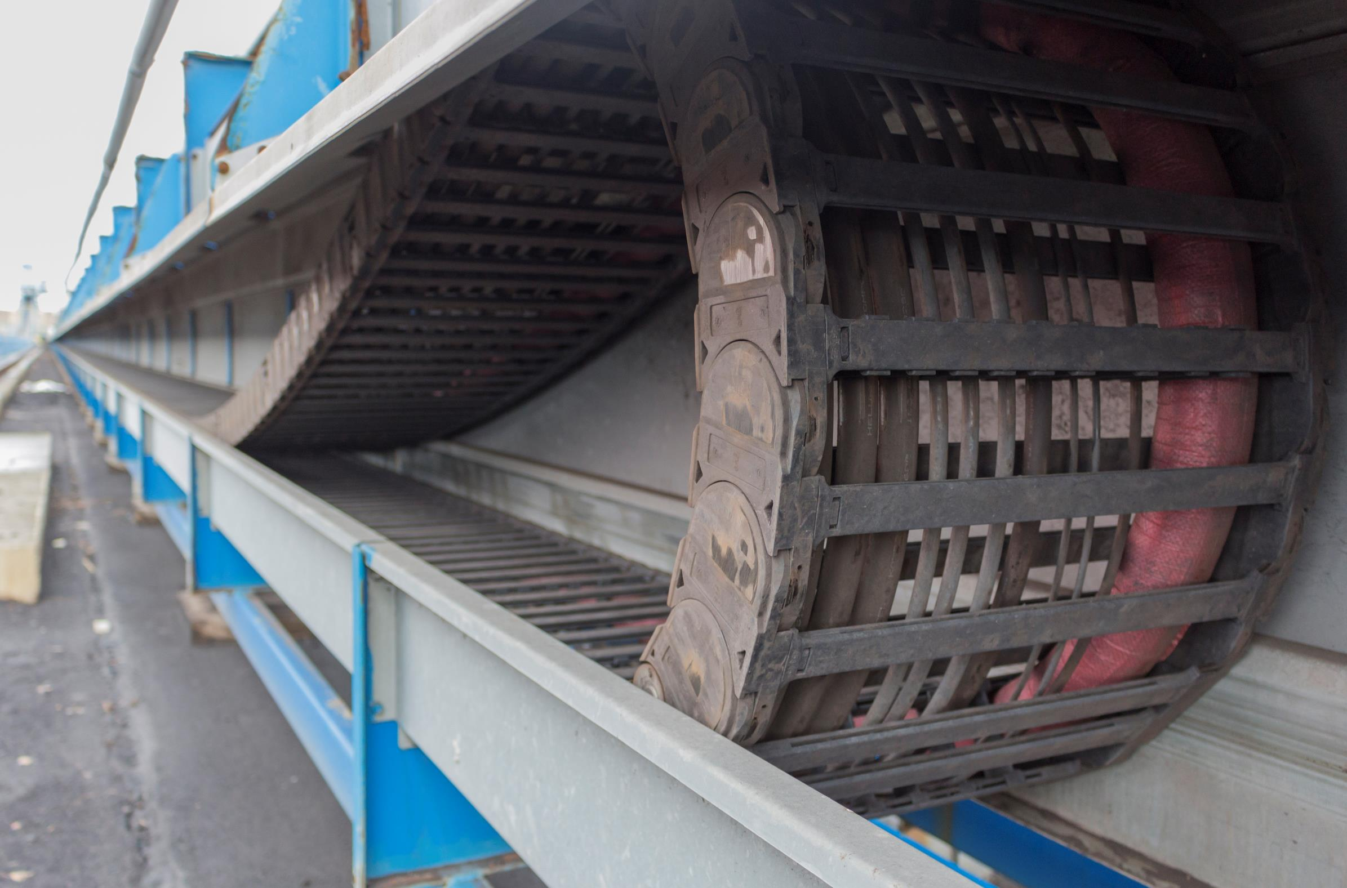
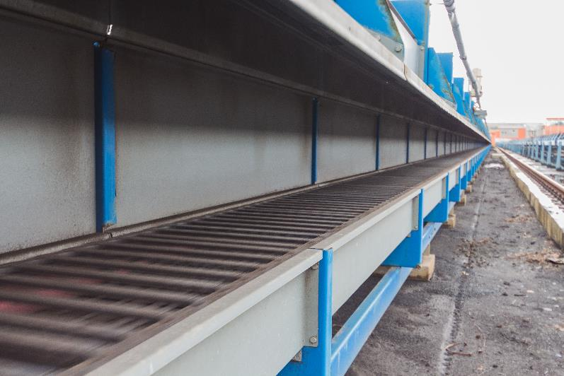
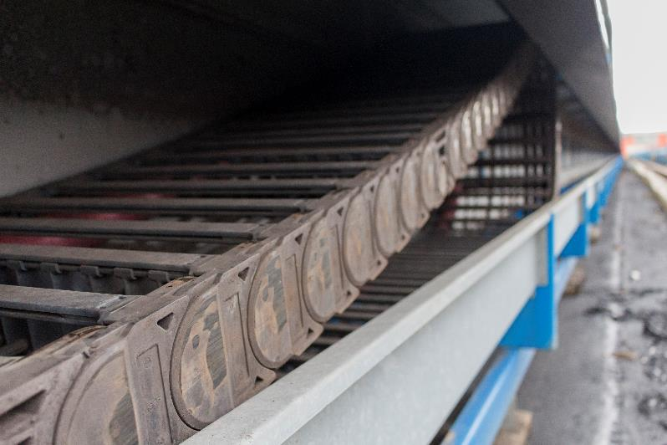
Image FA1418-3a, -3b and -3c
In ten years of operation here, only a few plastic crossbars have been replaced. (Source: igus GmbH)

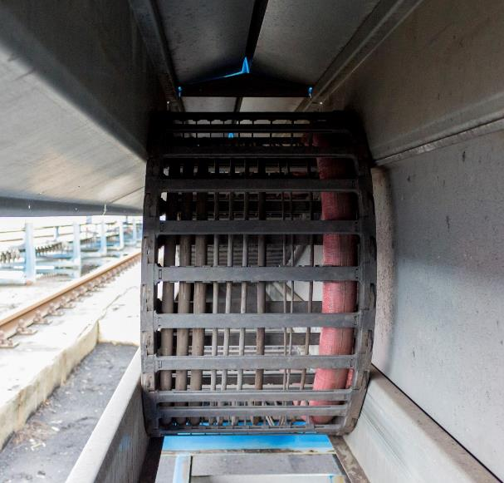
Image FA1418-4
In addition to the motor, control and data cables, a water hose is routed in the energy chain of the 5050RHD series (here right in the chain), which can be heated. (Source: igus GmbH)

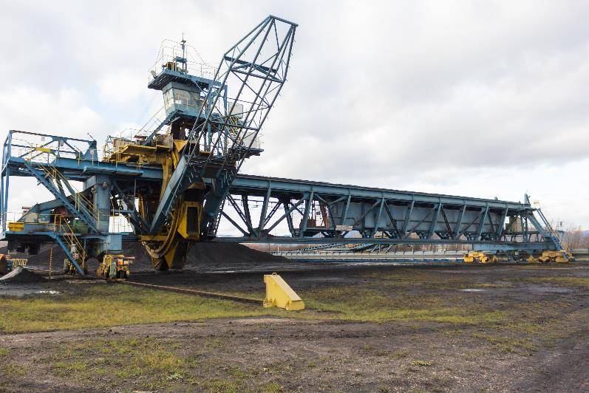
Image FA1418-5
In addition to the record-breaking travel, two further energy chain systems from igus are in operation in Tušimice, supplying the reclaimer at the coal heap. These have also been in operation for ten years without failure, having travels of 400 and 150 metres. (Source: igus GmbH)

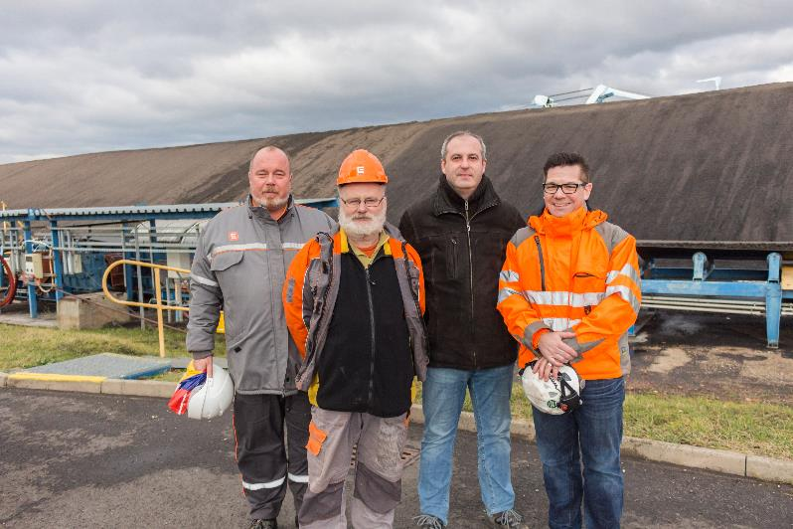
Image FA1418-6
Successful cooperation. From left to right: Ladislav Kříž, František Farkaš (both ČEZ), Jan Švarc (Hennlich CZ), Frank Schlögel (igus). (Source: igus GmbH)

